Benguet State University granted the ***FREE use of its facilities*** (Gymnasium, Covered Court, Tables, and Chairs) for the Local Government Unit (LGU) of La Trinidad in their **COVID-19 Mass Vaccination**.

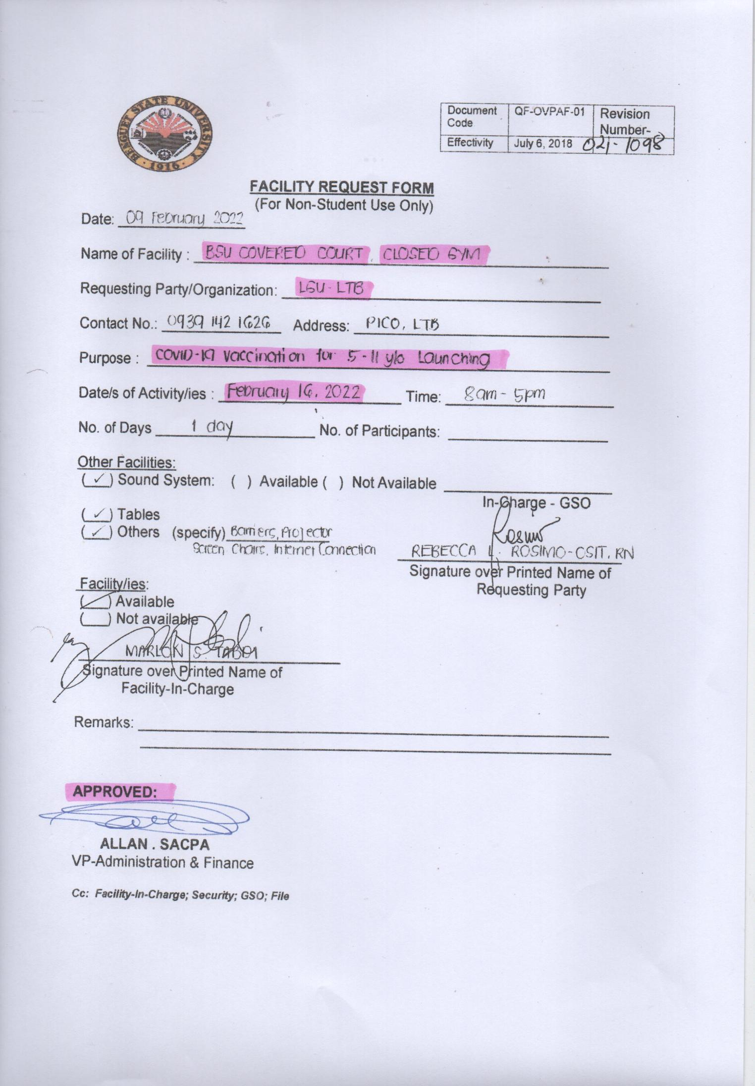

The ***BSU - College of Nursing*** also extended their assistance through the provision of ***available nurses as Vaccinators*** during the ***COVID - 19 Mass Vaccination*** in the centers located in the barangays of La Trinidad.

