The Benguet General Hospital (BeGH) and the Baguio General Hospital and Medical Center (BGHMC) has been engaged to provide training for the Nurse Learners and the Nutrition and Dietetics (ND) Learners. With the said collaboration, the University was able to provide quality training for future nurses and nutritionist and dieticians that will provide quality health care services.

BENGUET GENERAL HOSPITAL

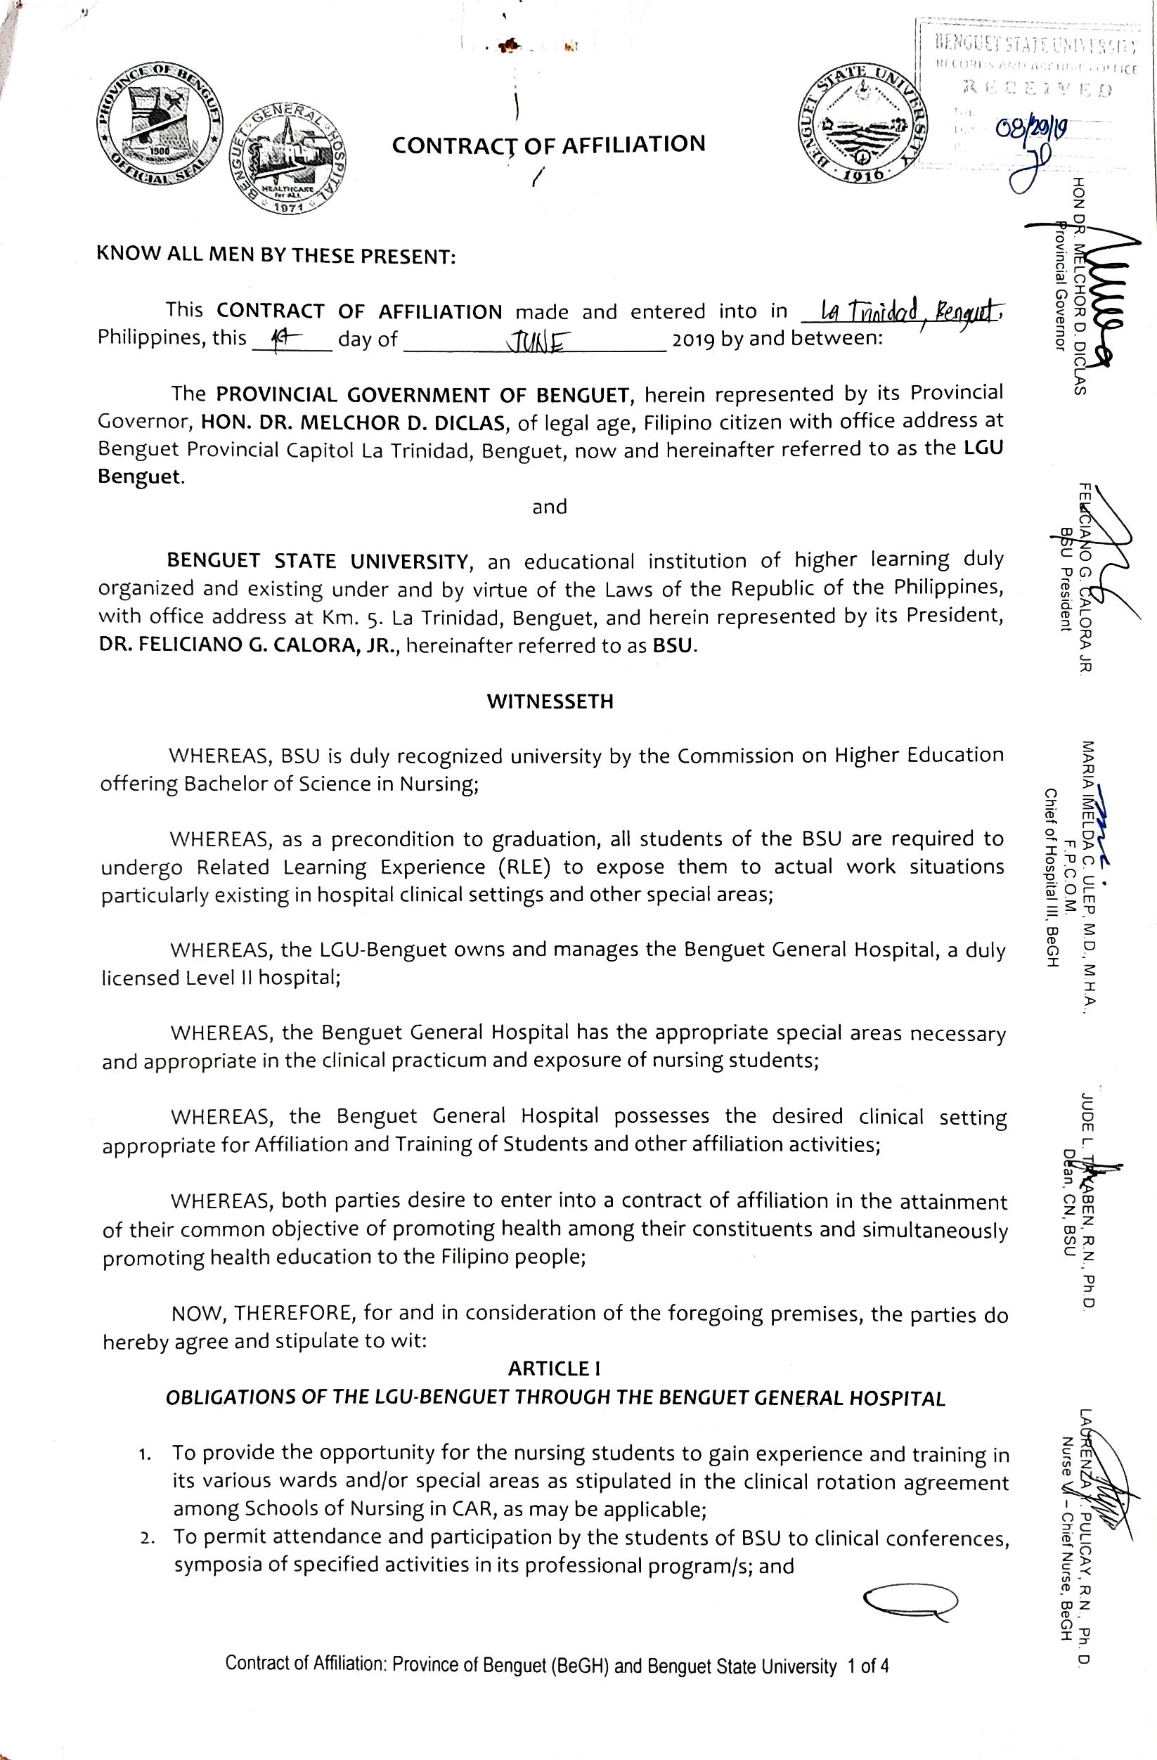

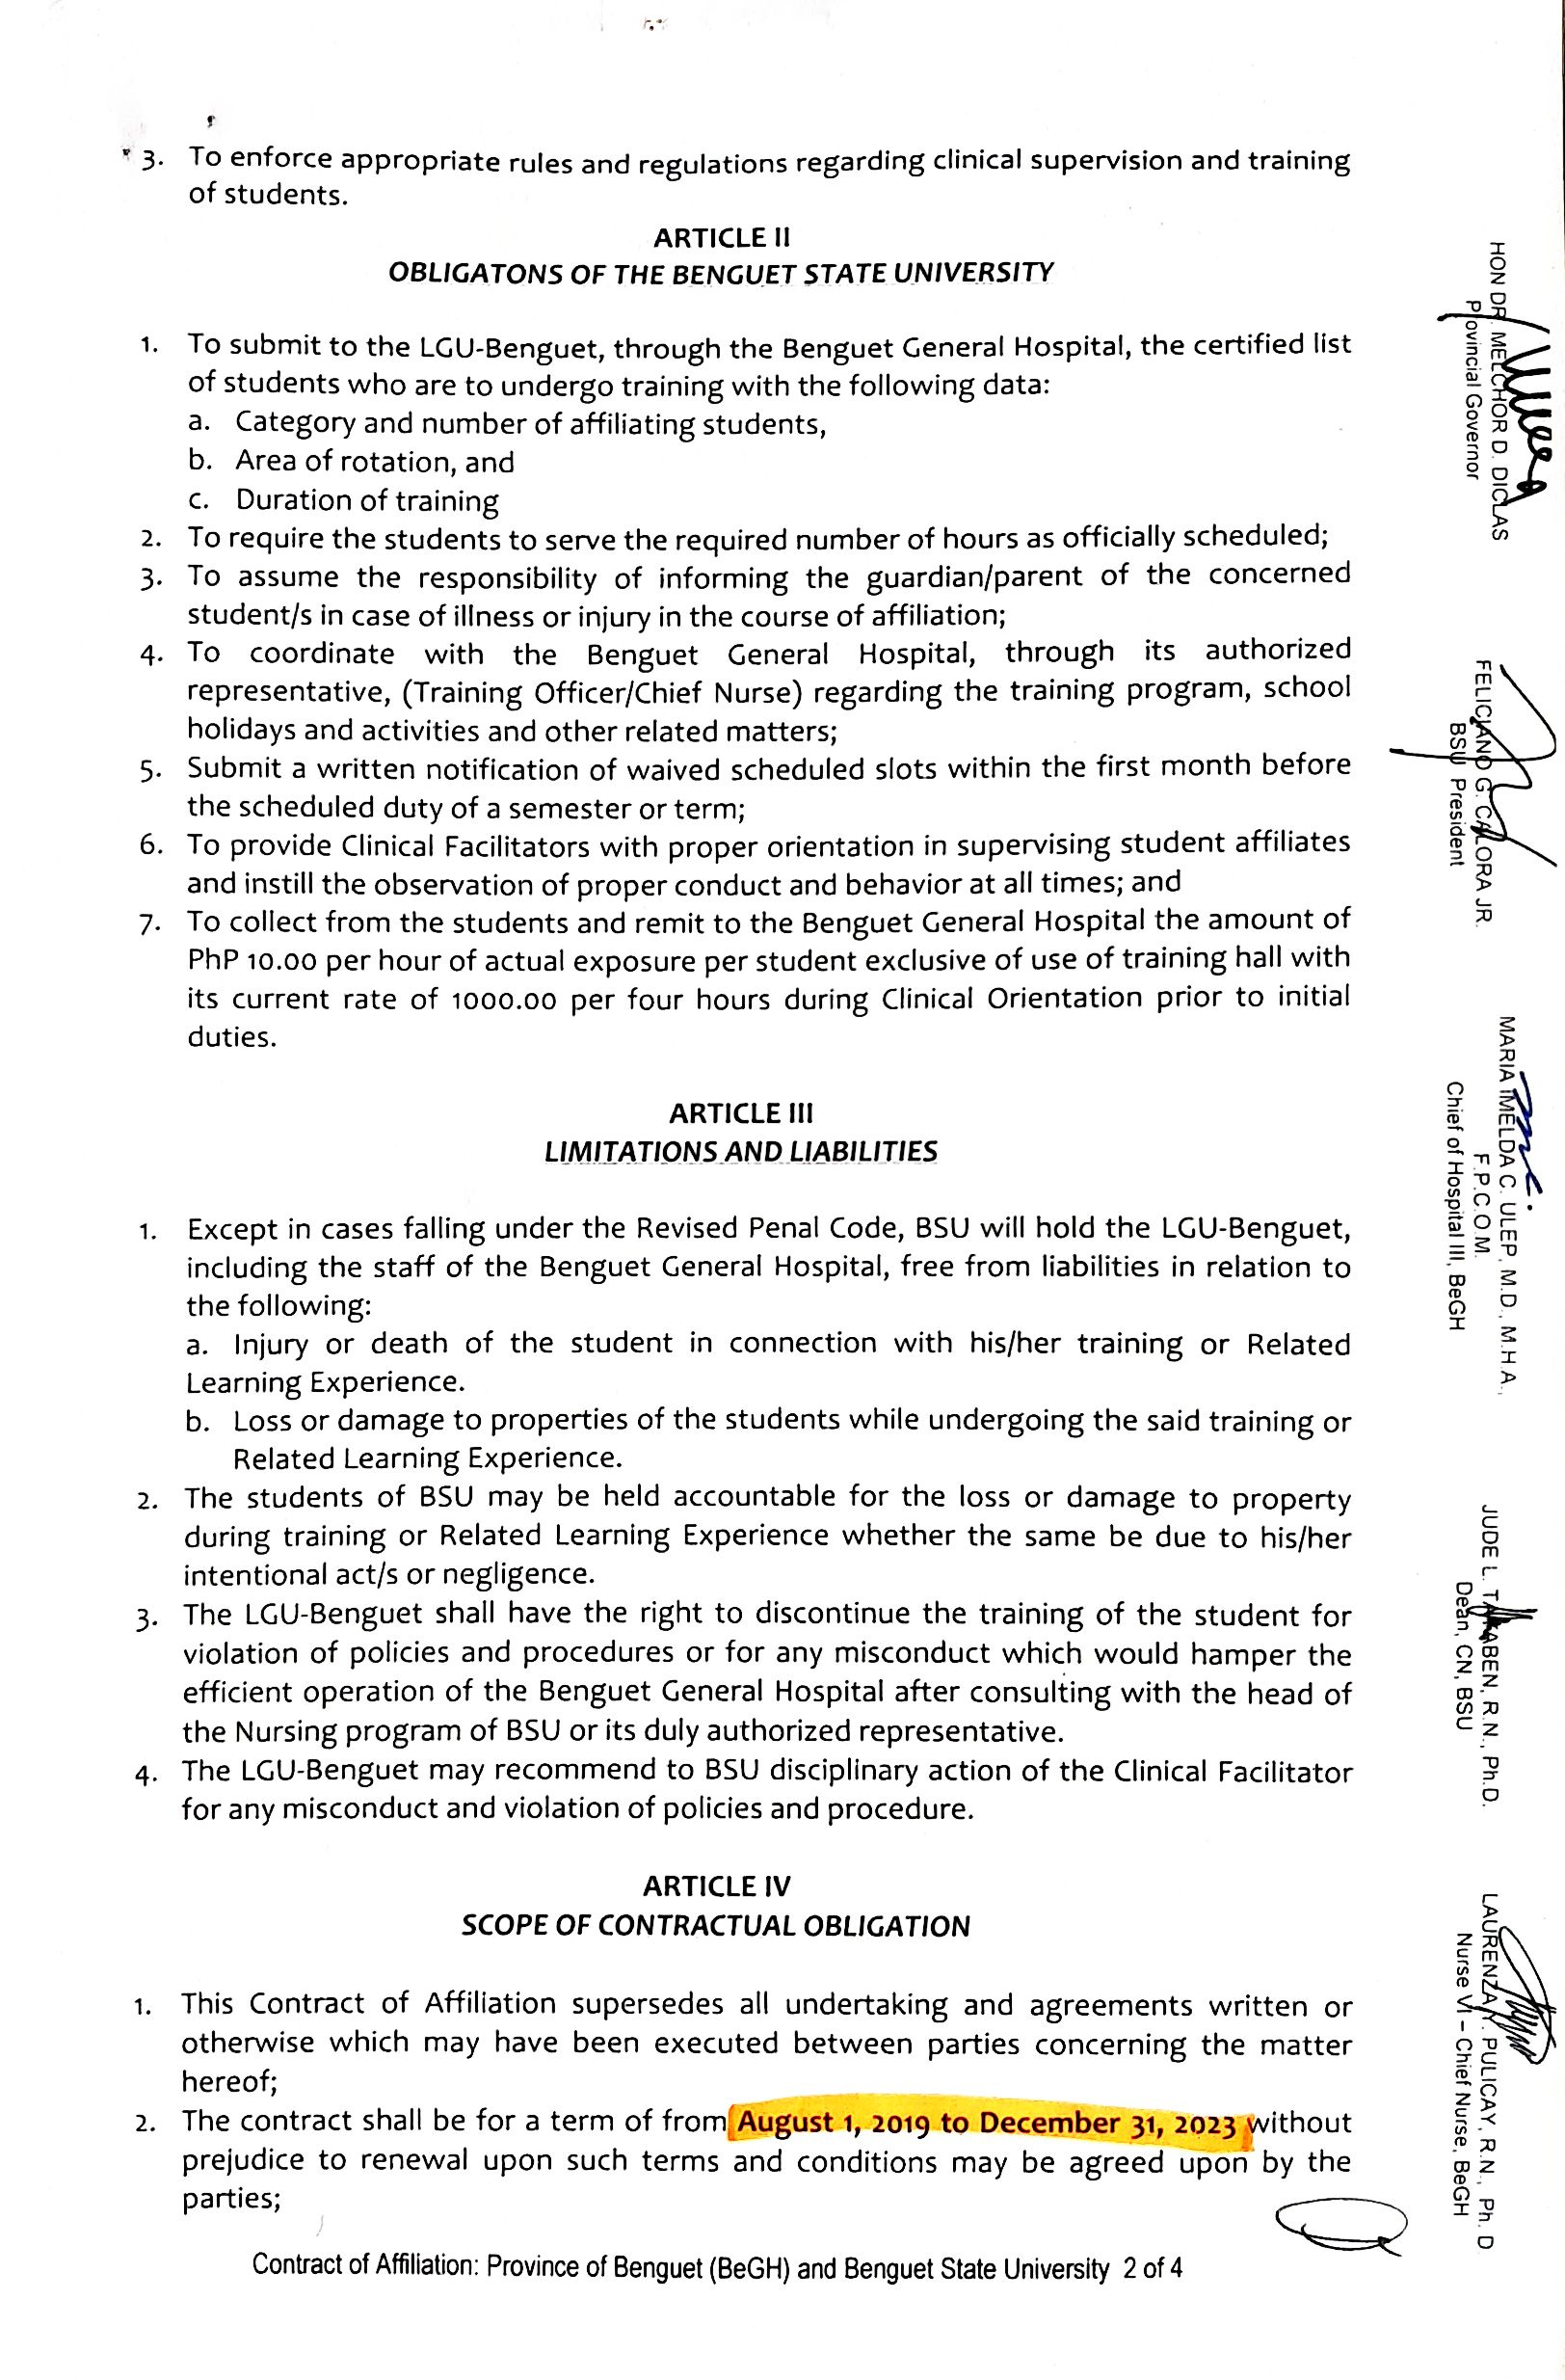

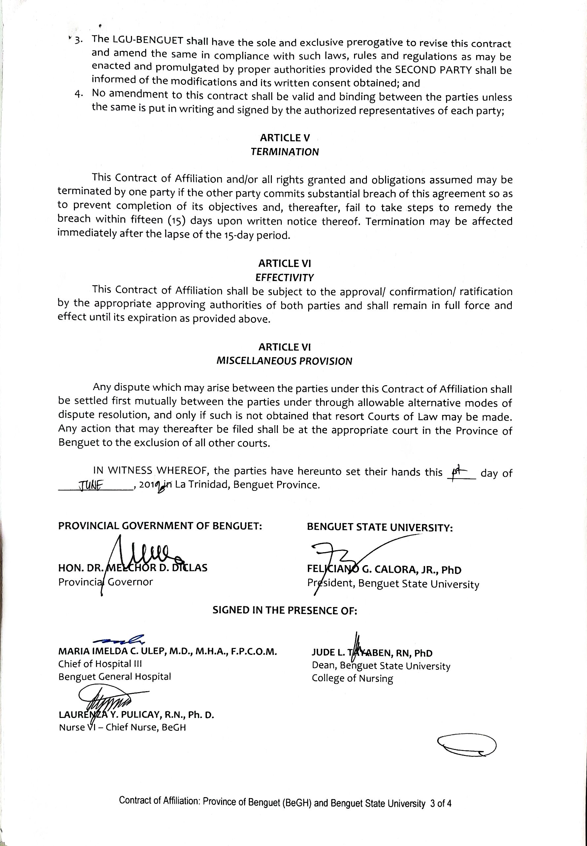

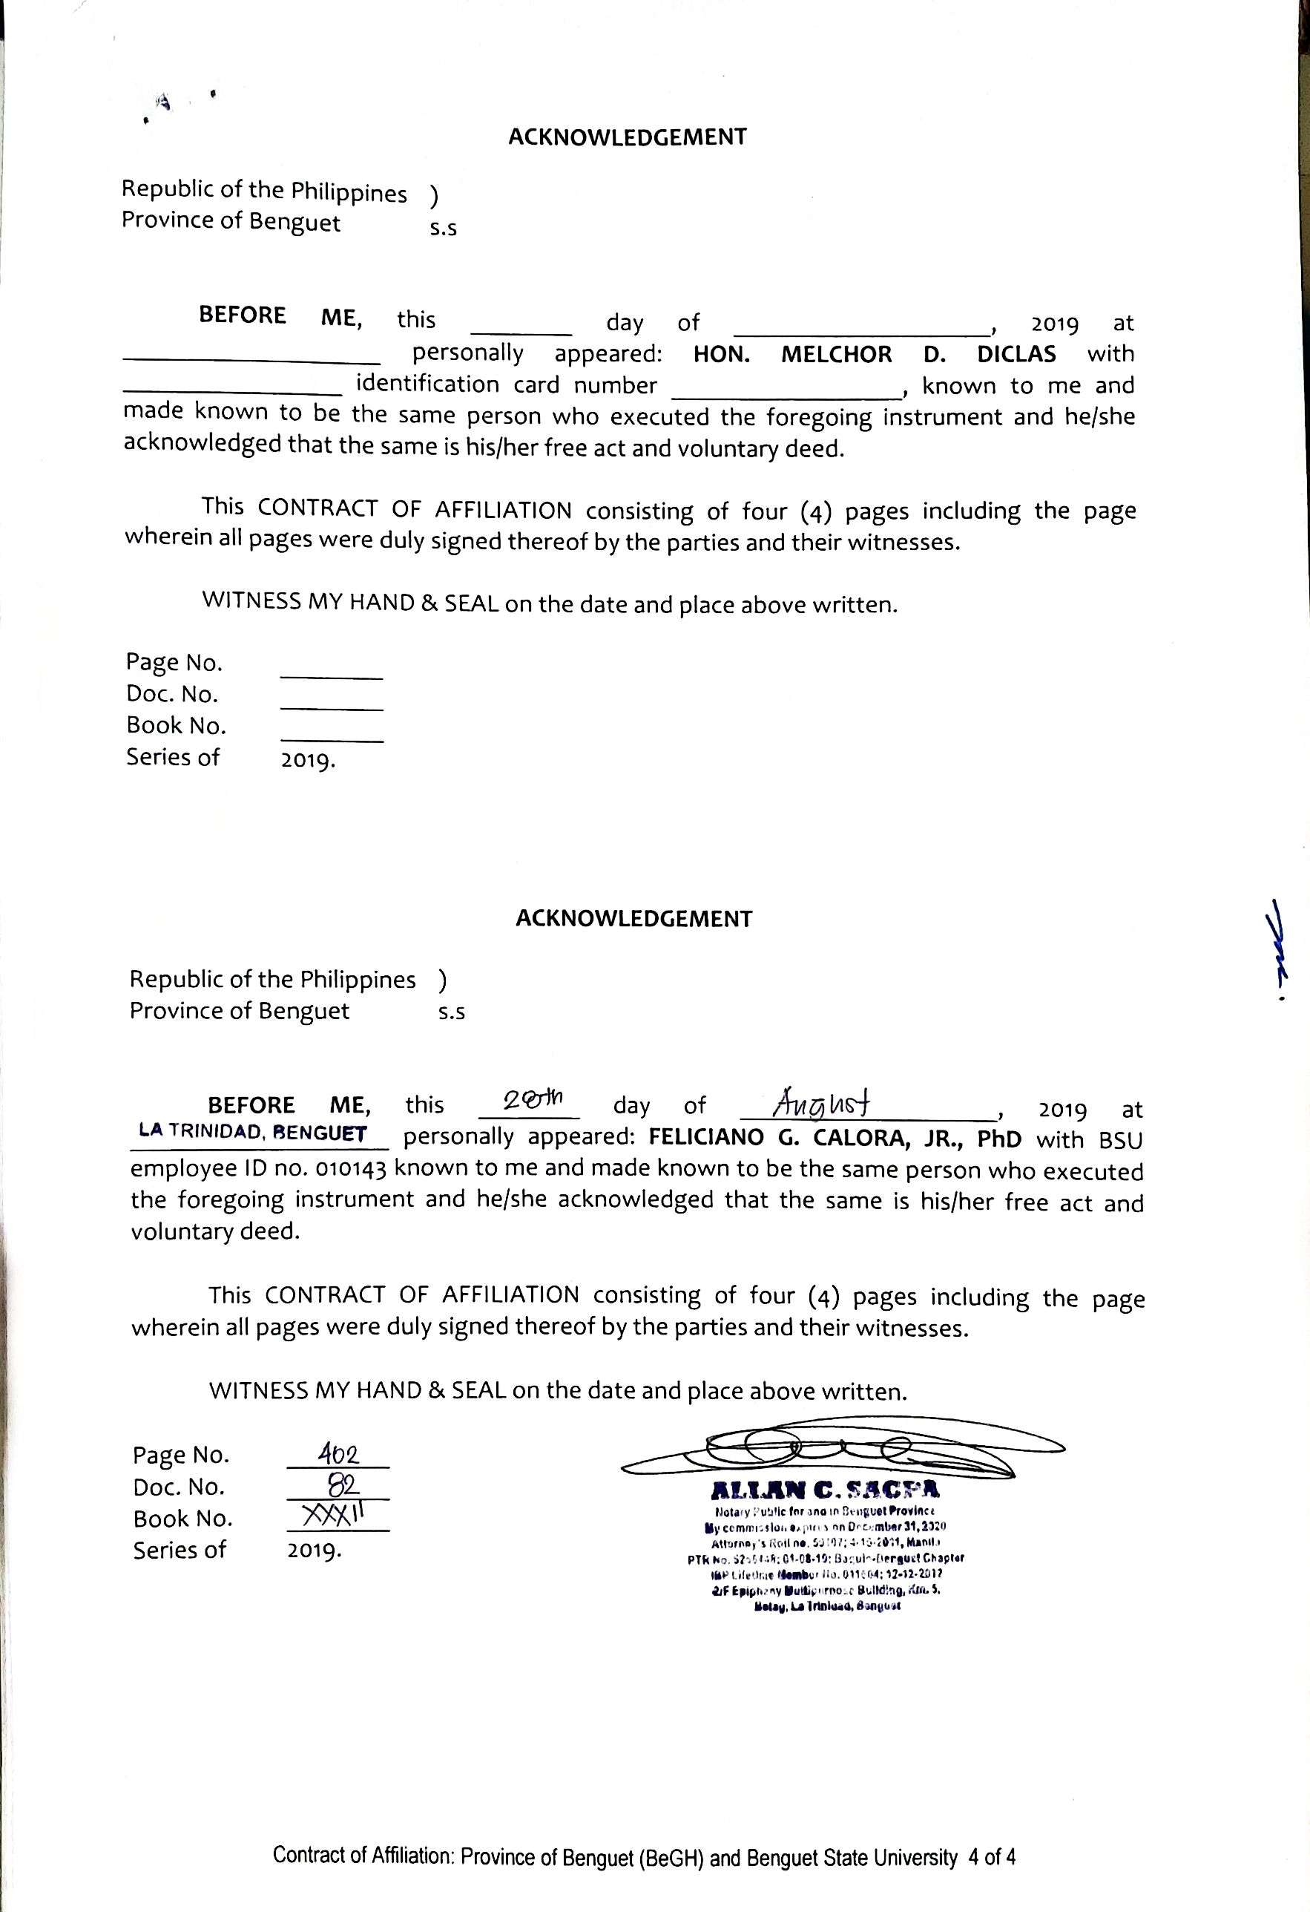

BAGUIO GENERAL HOSPITAL AND MEDICAL CENTER (BGHMC)

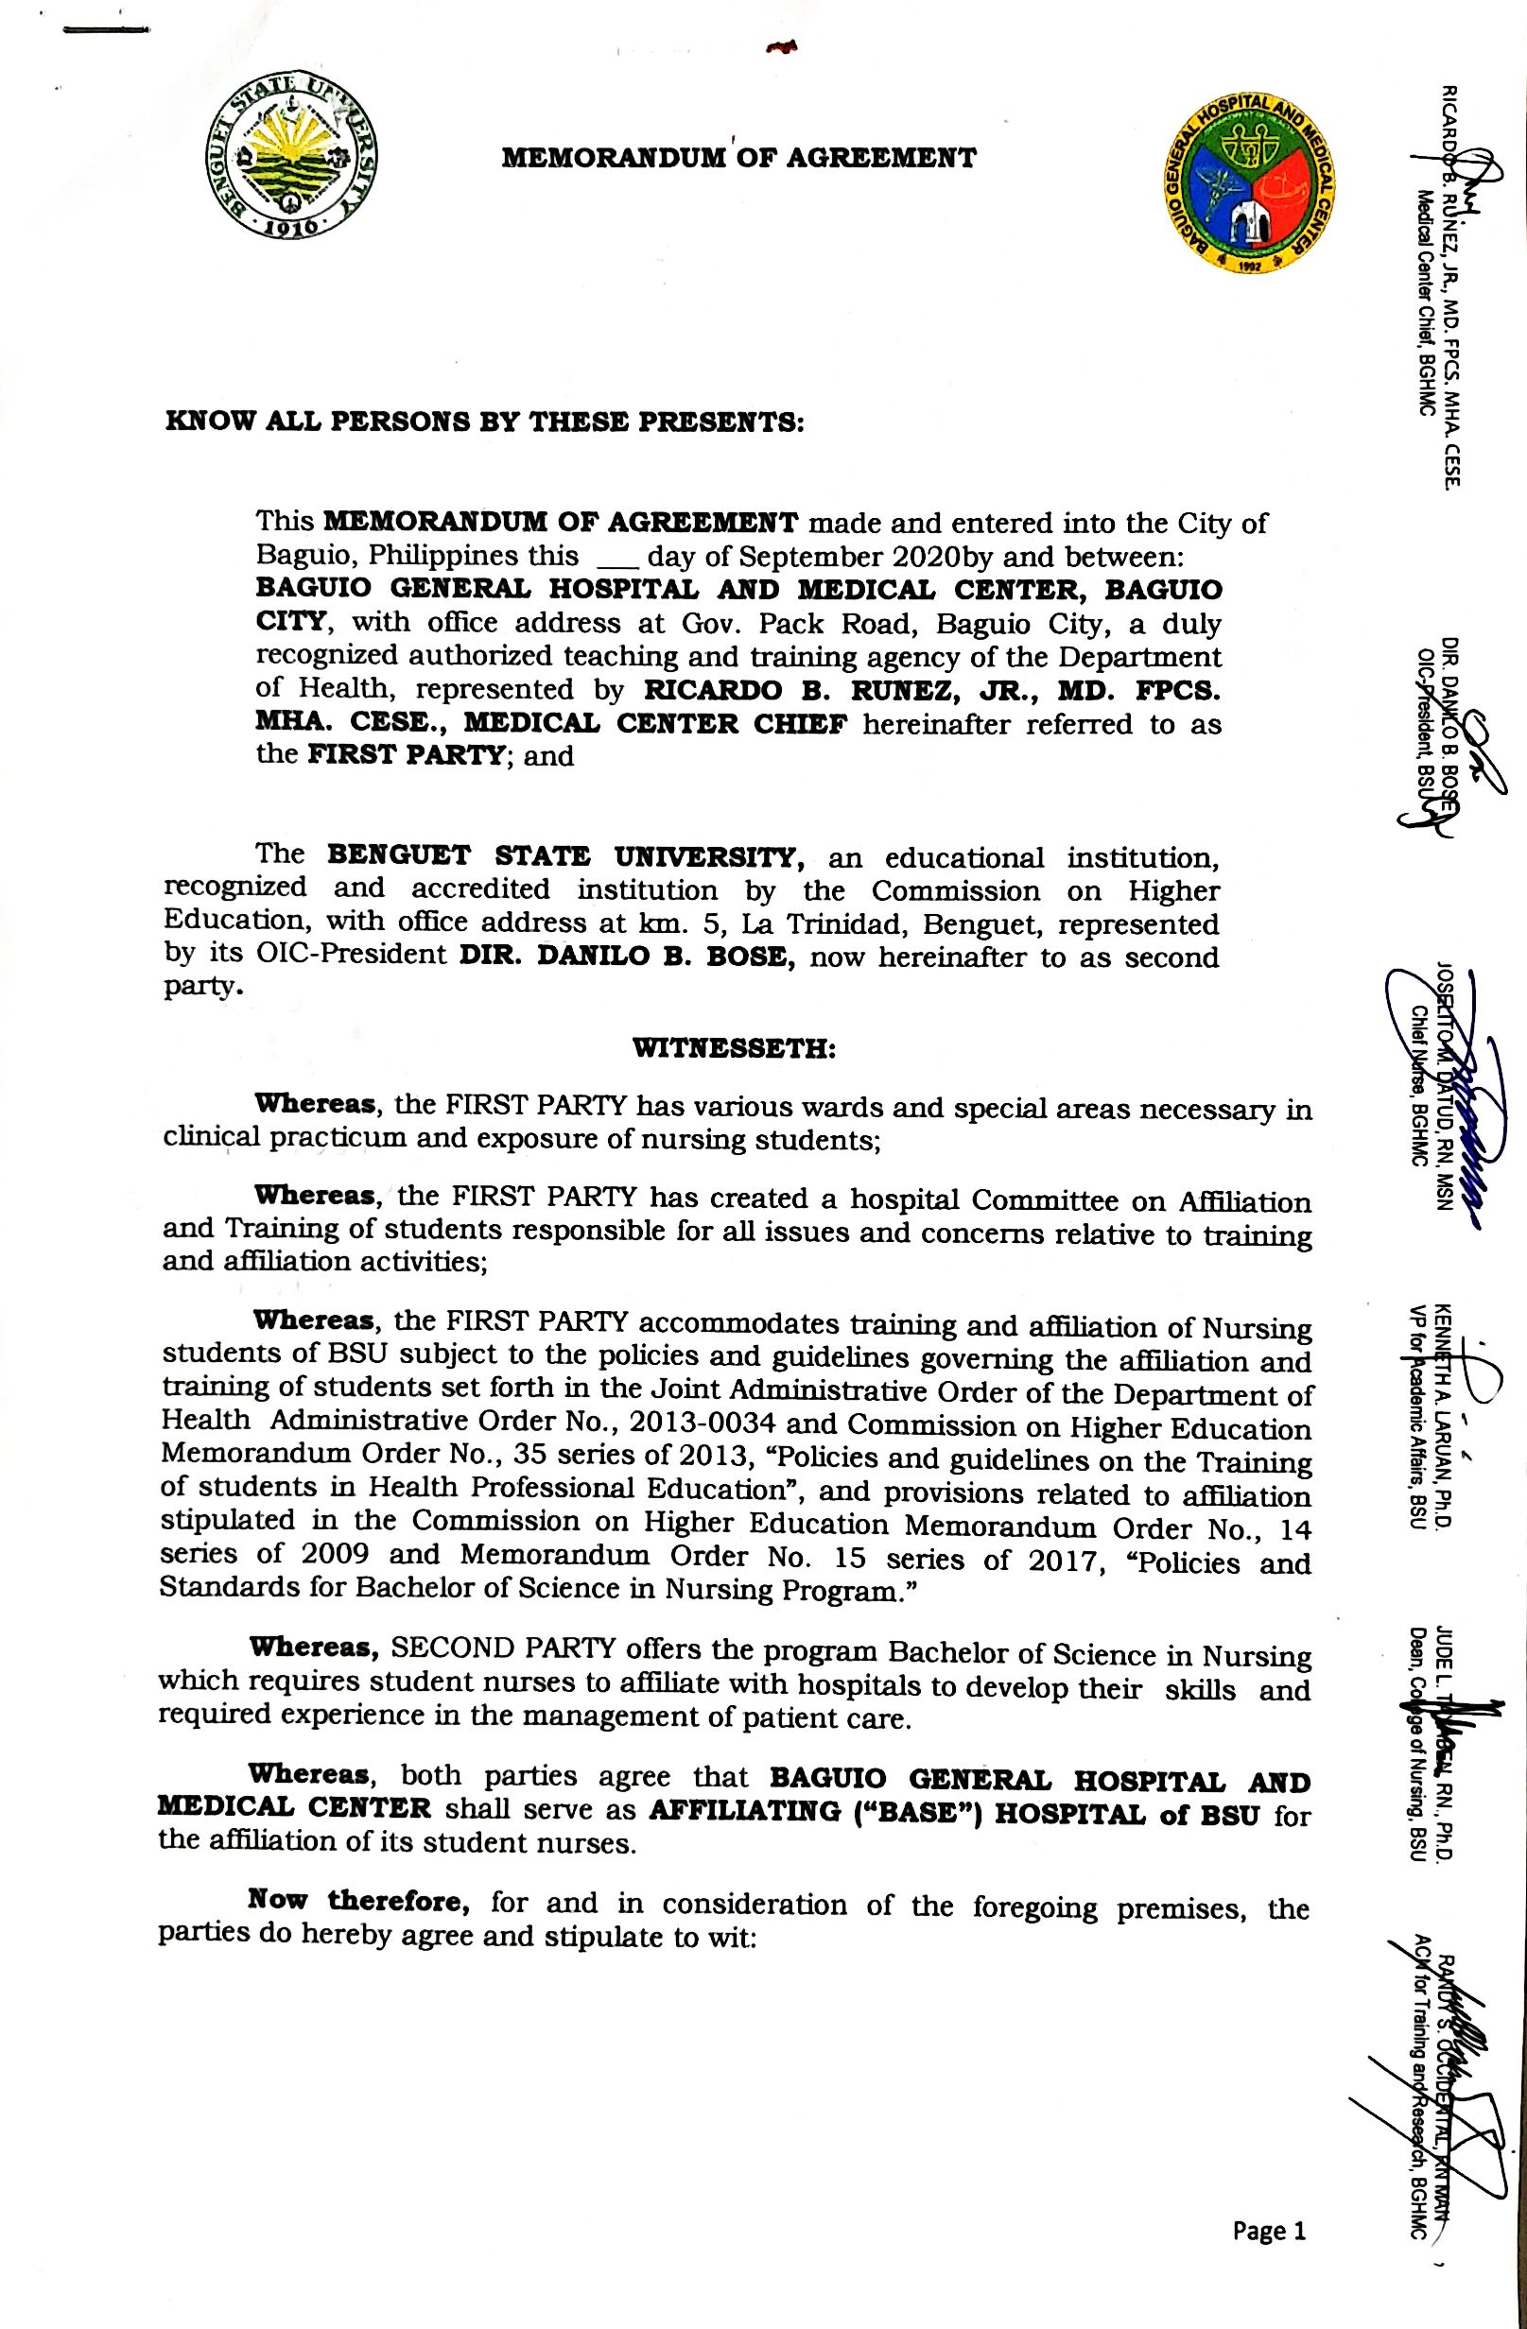
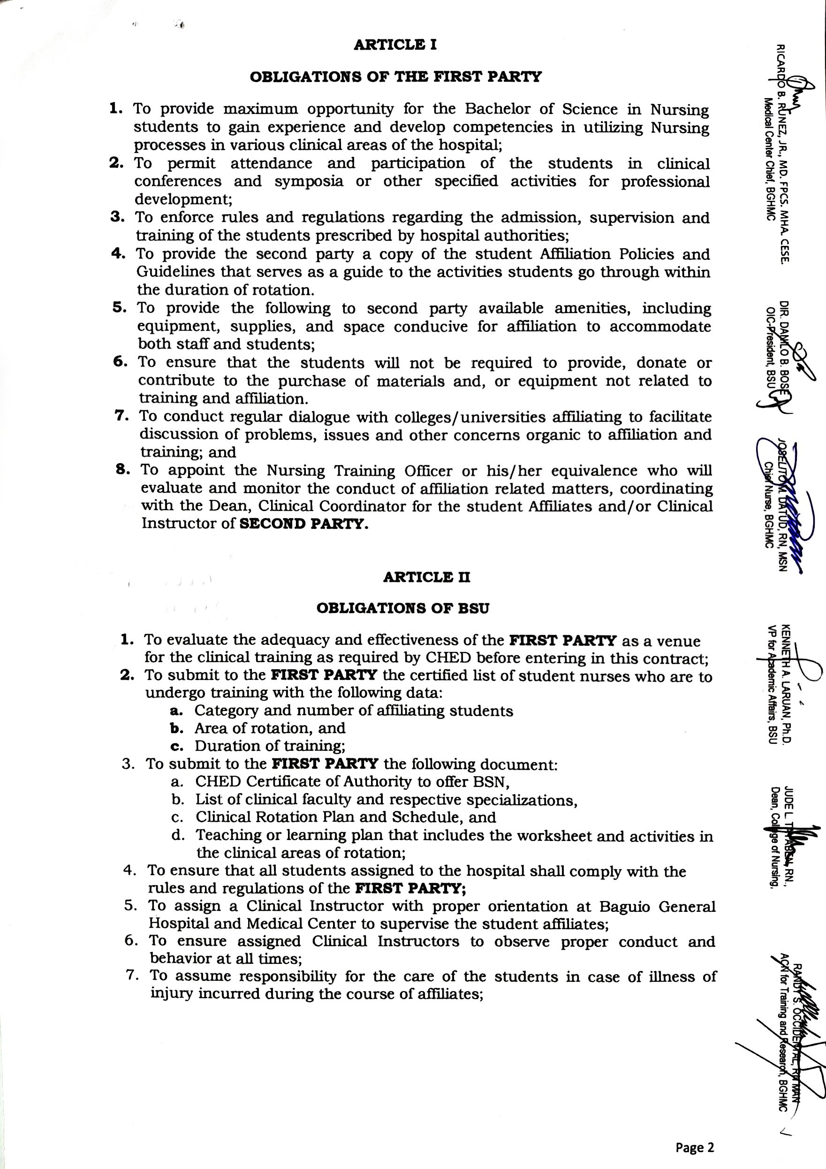

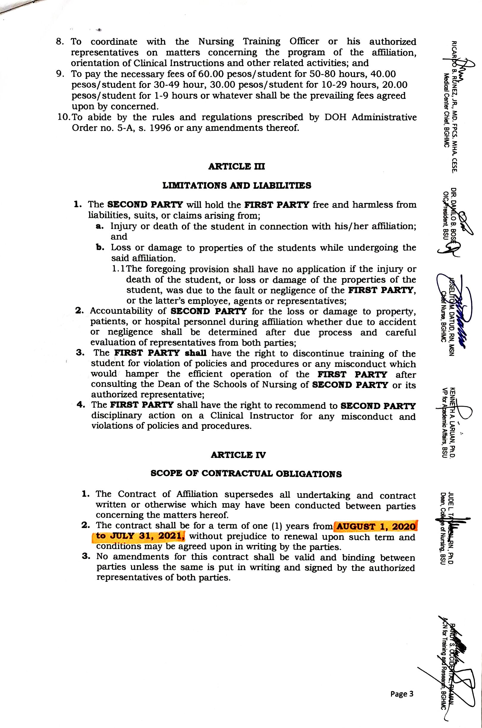

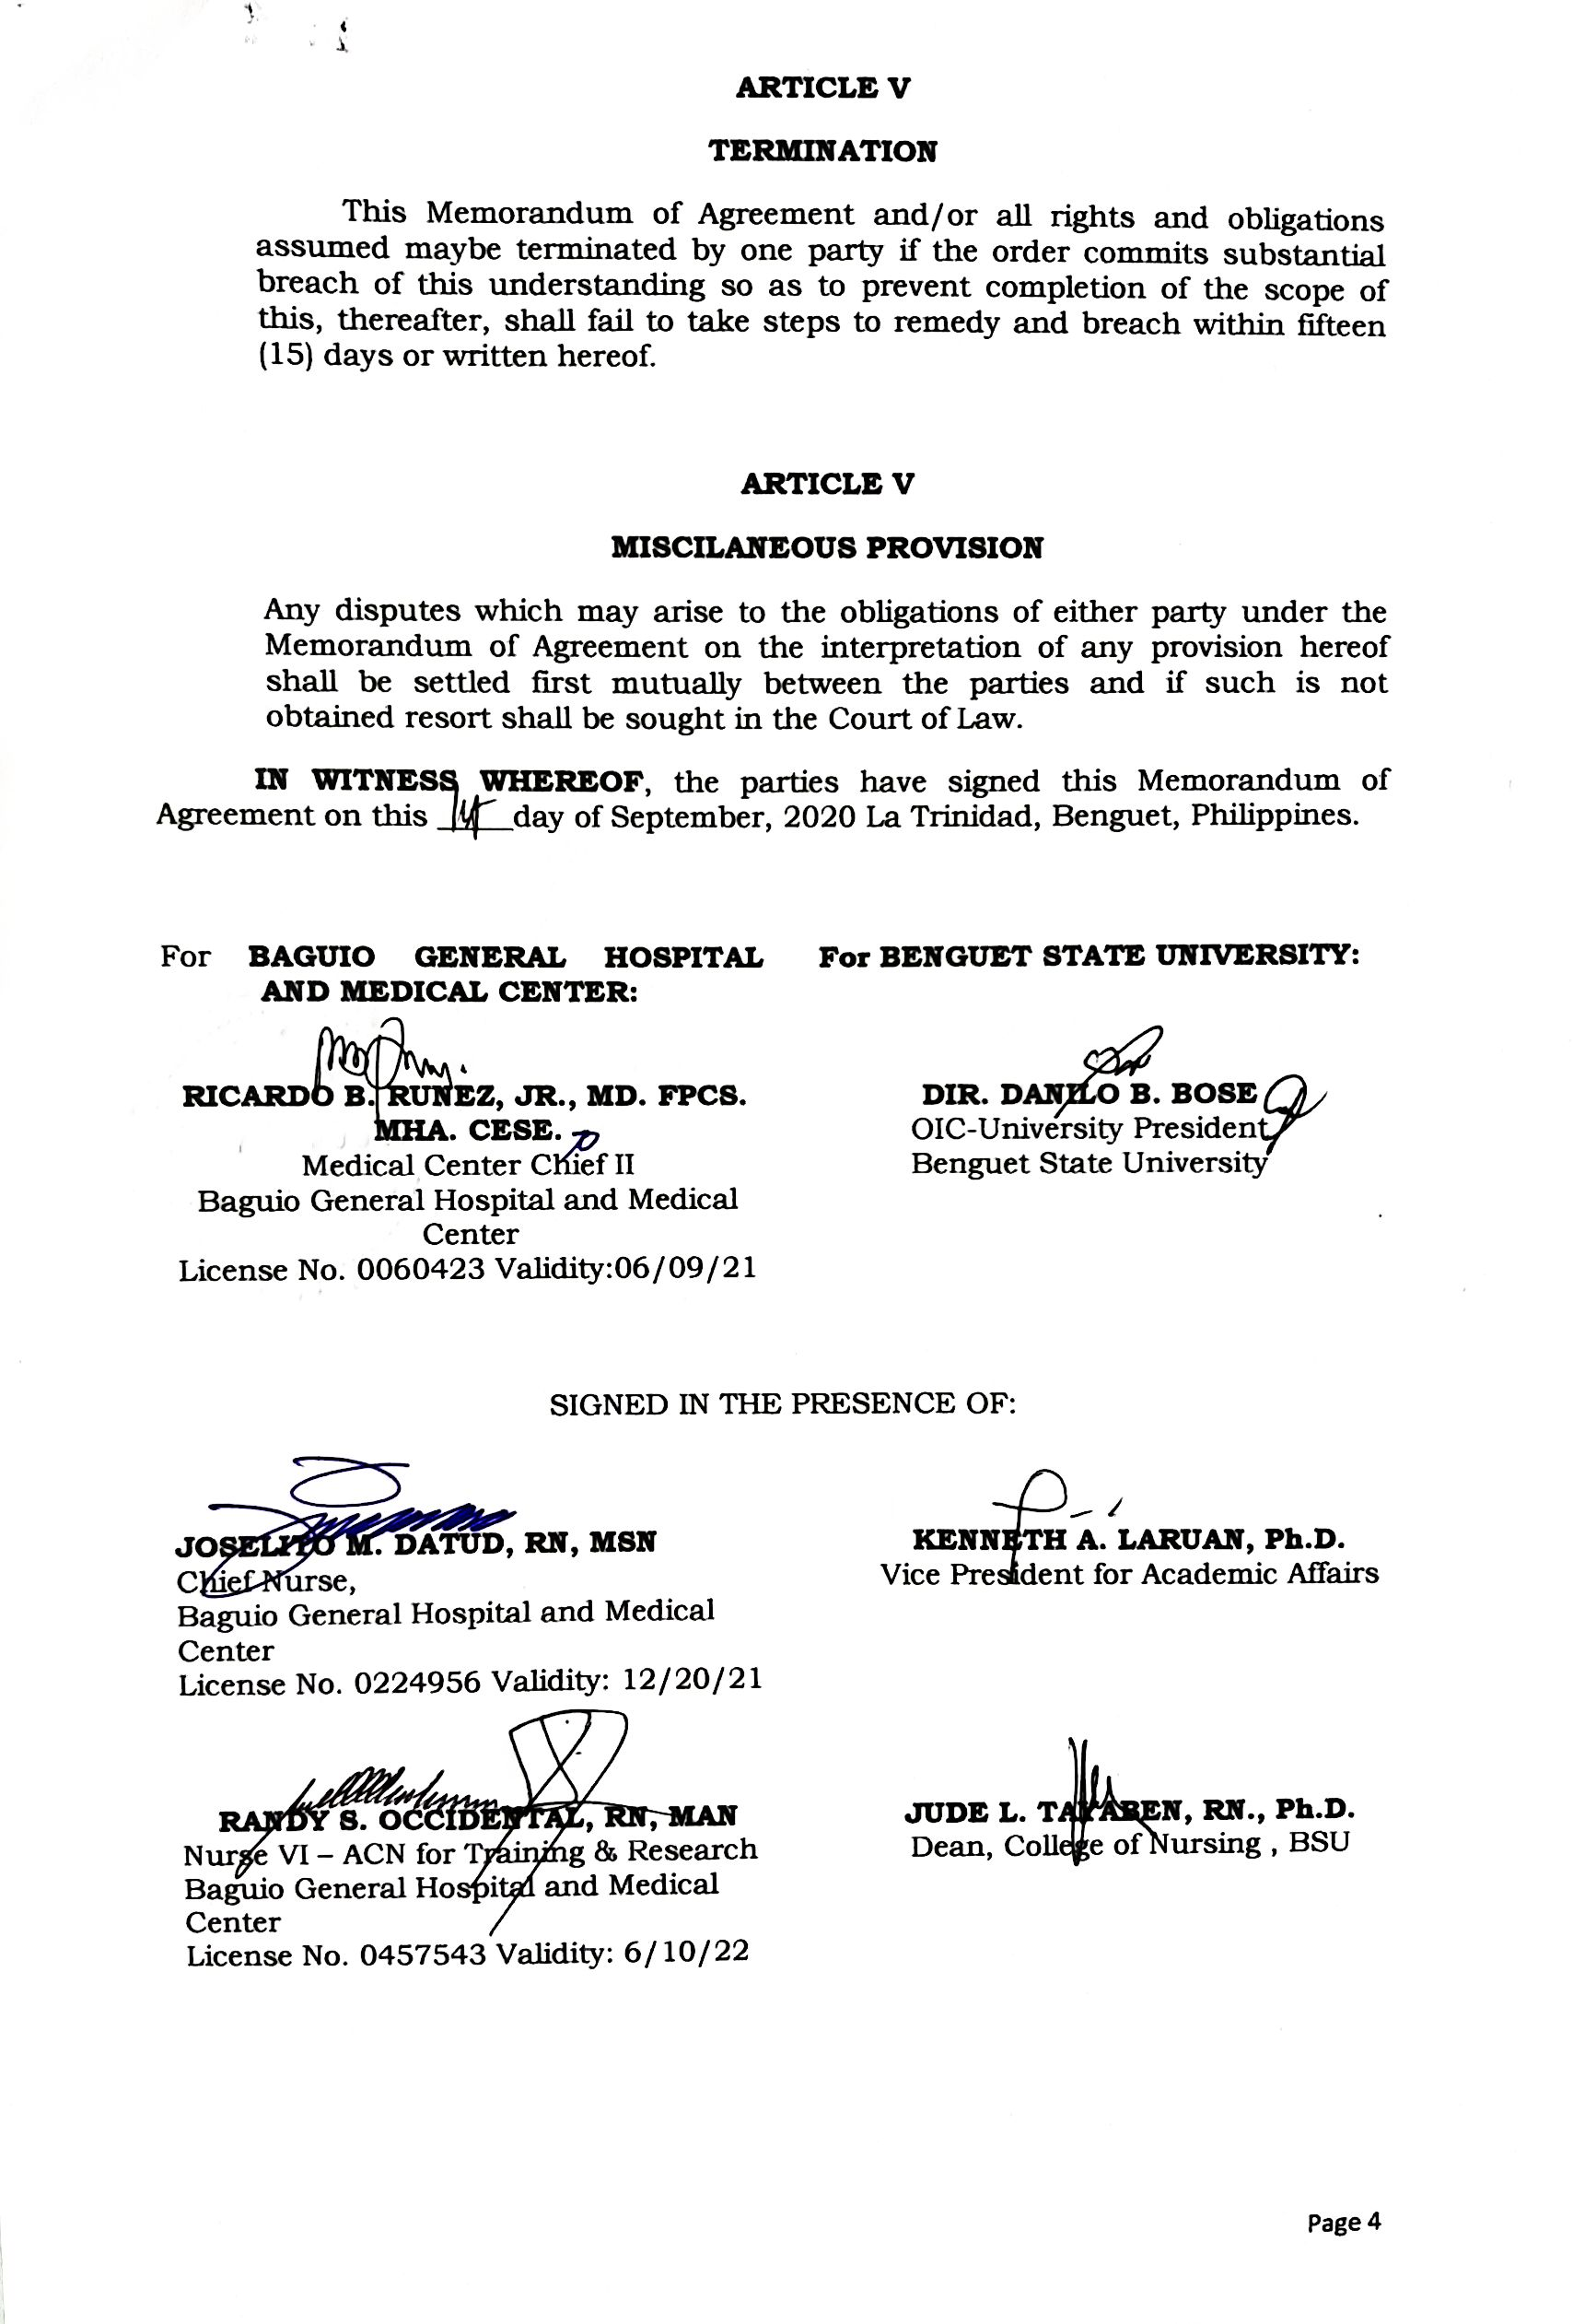

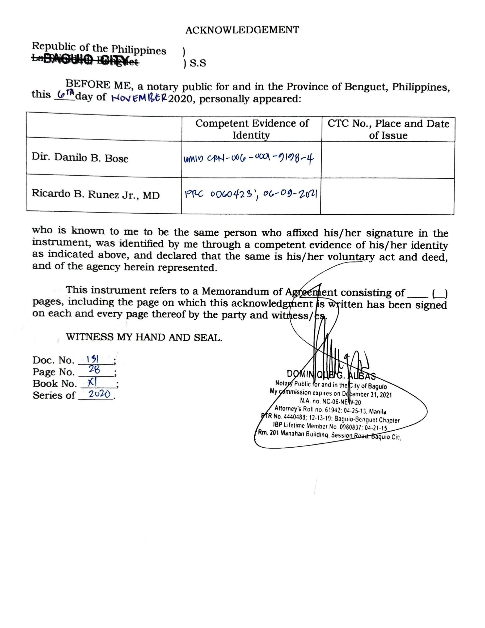

ILOCOS TRAINING AND REGIONAL MEDICAL CENTER (BGHMC)
