The Benguet State University is committed in the maintenance of physical health and well being of the community and other stakeholders. Thus, BSU has accorded the use of its sports facilities ***to the community for Free or with charges.***

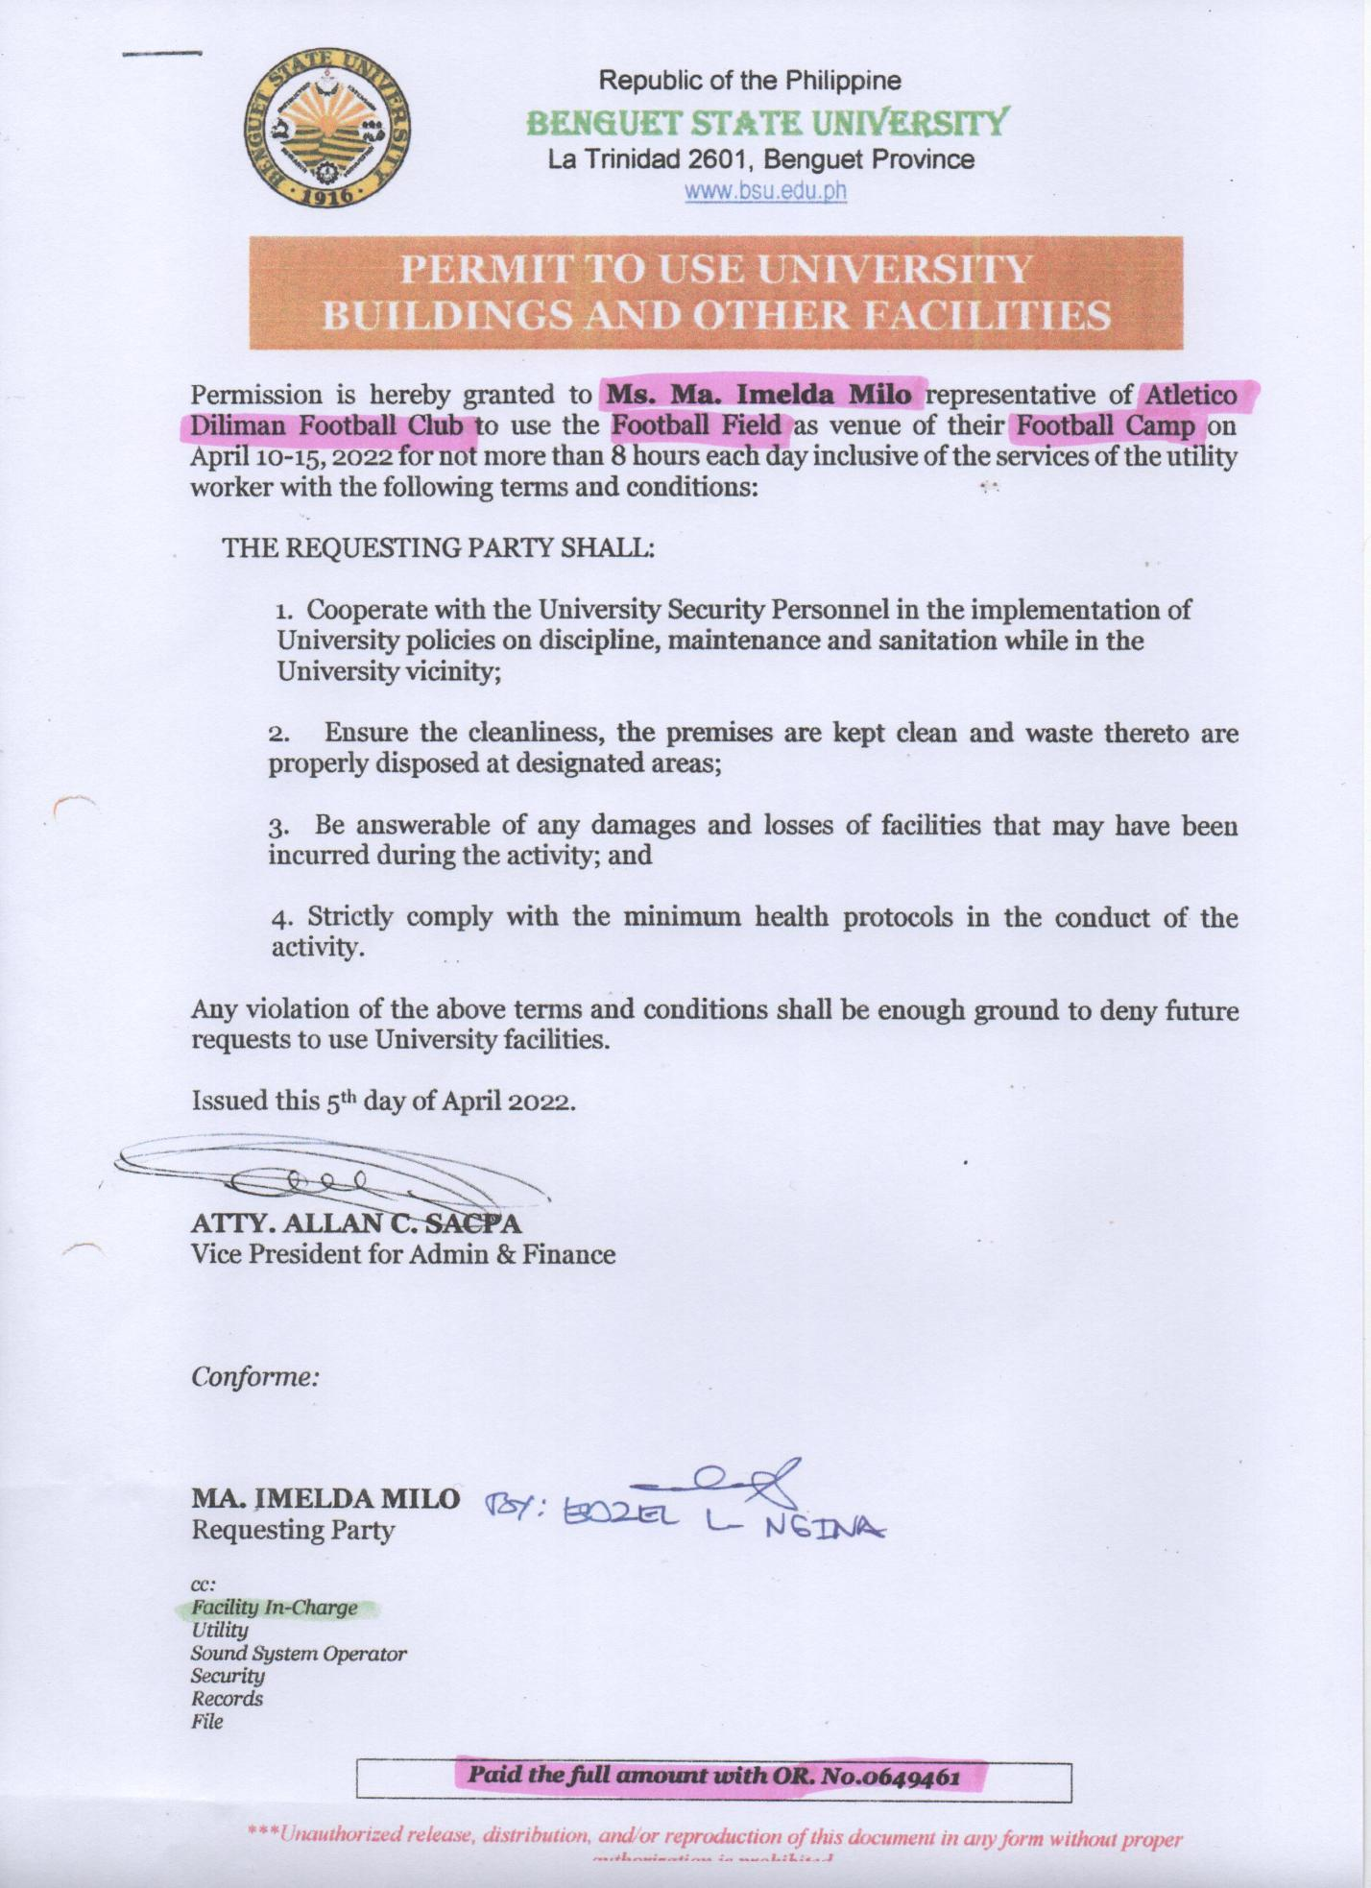

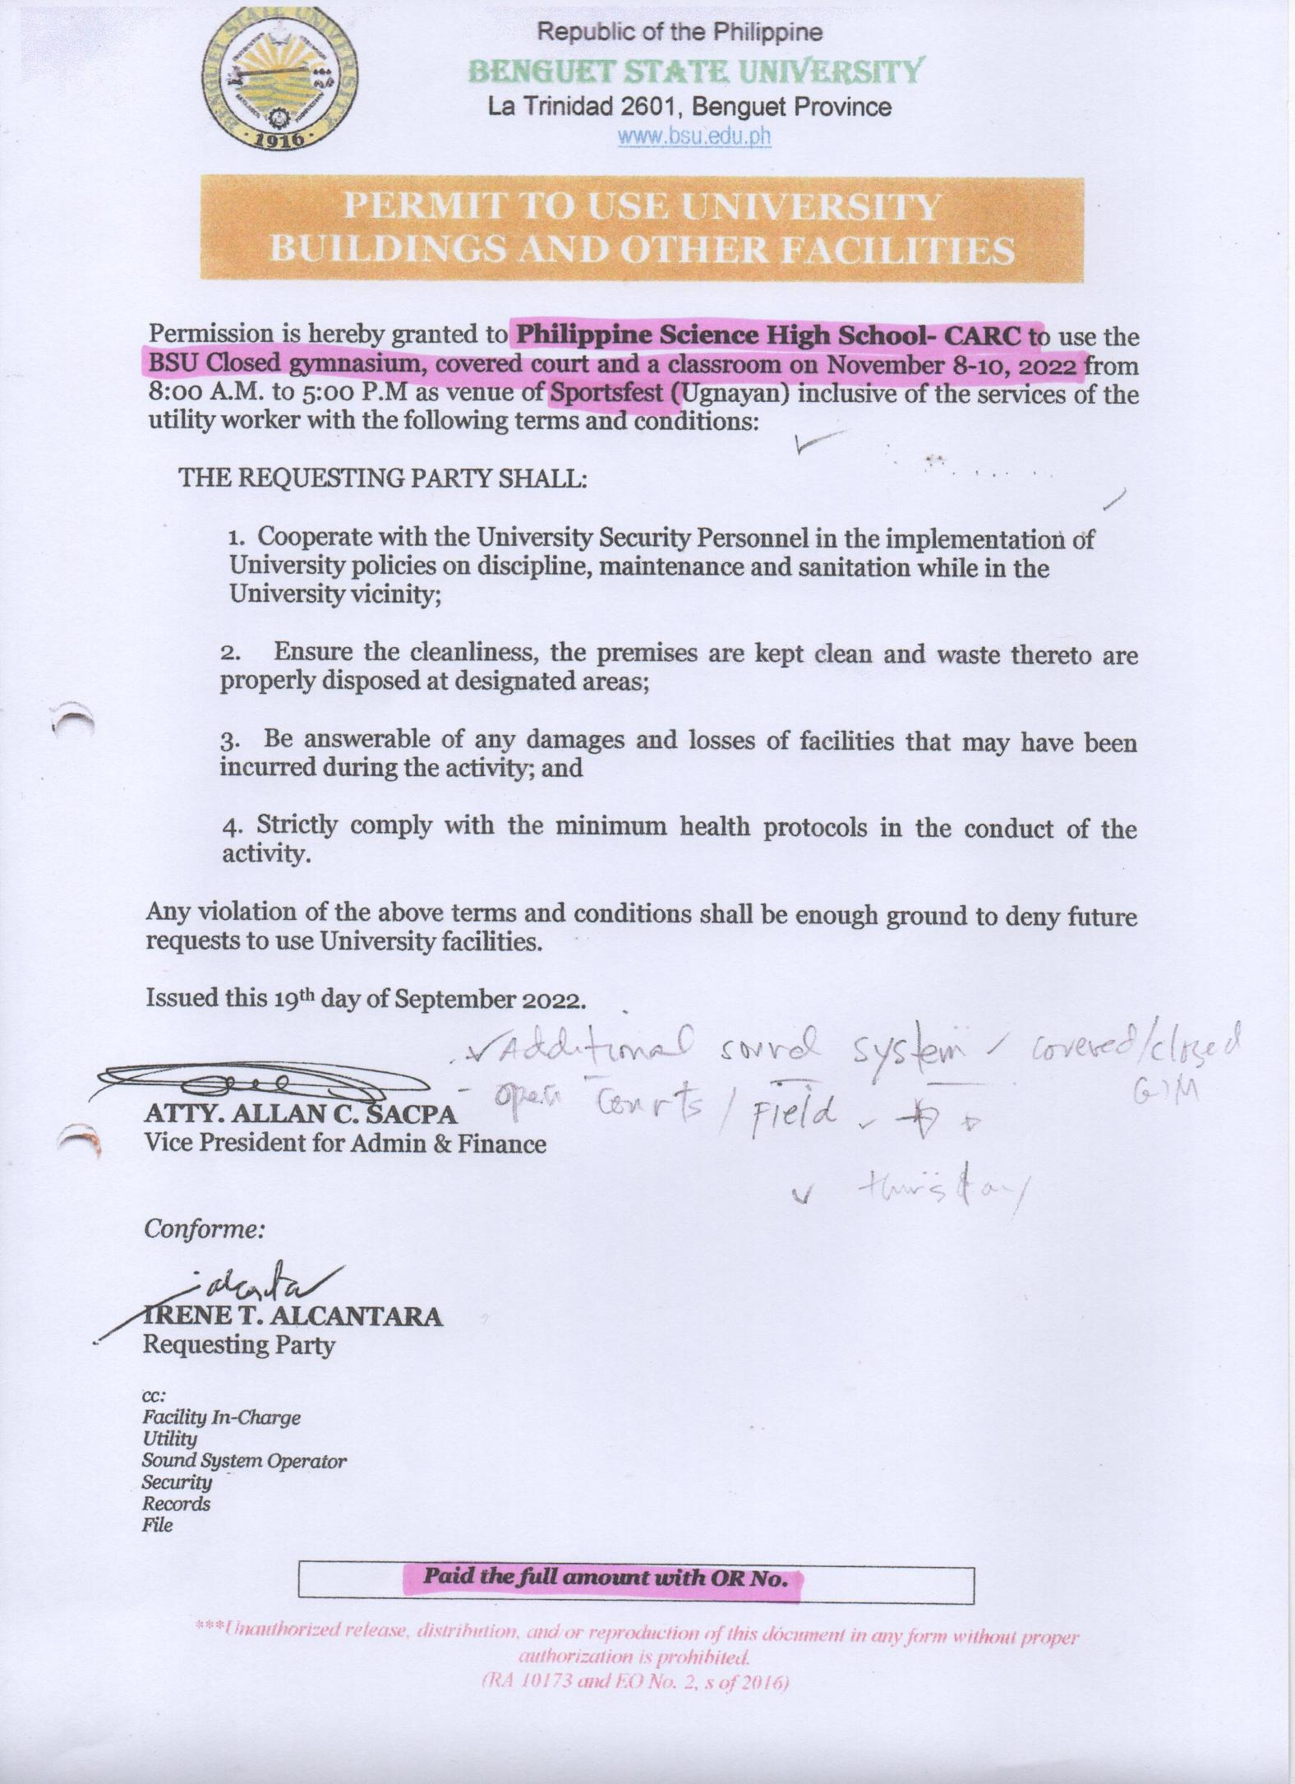

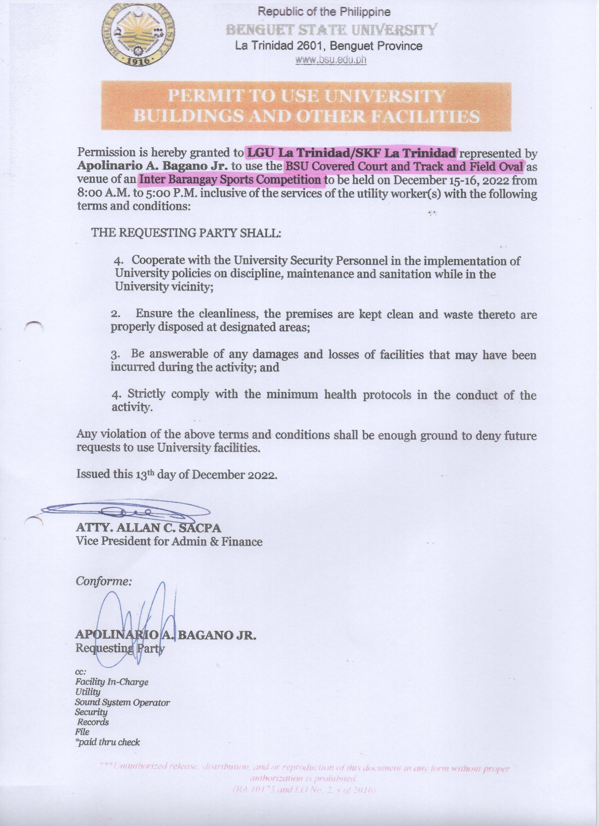

The Benguet State University is committed in the maintenance of physical health and well being of its employees and other stakeholders. Thus the F.I.T. (Fitness, Inspiration and Transformation) Habit and other health related activities for students and employees are accorded as free.

